CODES FOR USE ON SURFACE AND GROUNDWATER MONITORING FORMS

Major Watershed(s) Affected: Use these for Basin Codes

Big Sandy River (BS) Mississippi River (MS)
Cumberland River, Upper (CU) Ohio River (OH)
Cumberland River, Lower (CL) Salt River (ST)
Green River (GR) Tennessee River (TN)
Kentucky River (KY) Tradewater River (TW)
Licking River (LC) Tygarts Creek (TG)
Little Sandy River (LS)

County Codes
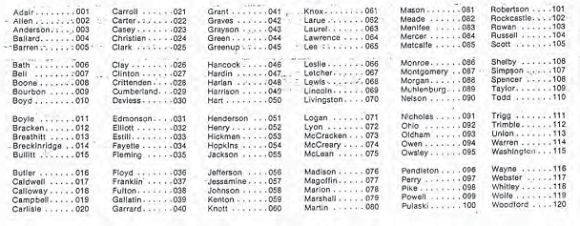

Adair 001
Allen 002
Anderson 003
Ballard 004
Barren 005
Bath 006
Bell 007
Boone 008
Bourbon 009
Boyd 010
Boyle 011
Bracken 012
Breathitt 013
Breckinridge 014
Bullitt 015
Butler 016
Caldwell 017
Calloway 018
Campbell 019
Carlisle 020
Carroll 021
Carter 022
Casey 023
Christian 024
Clark 025
Clay 026
Clinton 027
Crittenden 028
Cumberland 029
Daviess 030
Edmonson 031
Elliott 032
Fayette 034
Fleming 035
Floyd 036
Franklin 037
Fulton 038
Gallatin 039
Garrard 040
Grant 041
Graves 042
Grayson 043
Green 044
Greenup 045
Hancock 046
Hardin 047
Harlan 048
Harrison 049
Hart 050
Henderson 051
Henry 052
Hickman 053
Hopkins 054
Jackson 055
Jefferson 056
Jessamine 057
Johnson 058
Kenton 059
Knott 060
Knox 061
Larue 062
Laurel 063
Lawrence 064
Lee 065
Leslie 066
Letcher 067
Lewis 068
Lincoln 069
Livingston 070
Logan 071
Lyon 072
McCracken 073
McCreary 074
McLean 075
Madison 076
Magoffin 077
Marion 078
Marshall 079
Martin 080
Mason 081
Meade 082
Menifee 083
Mercer 084
Metcalfe 085
Monroe 086
Montgomery 087
Morgan 088
Muhlenberg 089
Nelson 090
Nicholas 091
Ohio 092
Oldham 093
Owen 094
Owsley 095
Pendleton 096
Perry 097
Pike 098
Powell 099
Pulaski 100
Robertson 101
Rockcastle 102
Rowan 103
Russell 104
Scott 105
Shelby 106
Simpson 107
Spencer 108
Taylor 109
Todd 110
Trigg 111
Trimble 112
Union 113
Warren 114
Washington 115
Wayne 116
Webster 117
Whitley 118
Wolfe 119
Woodford 120

